Digital Forensics Case Analysis

The domain of the Project: Digital Forensics

COURSE NAME: Cyber Security & Ethical Hacking

Team Mentors (and their designation):

Sen Hariharan(Security Technician at FCIPL)

Team Members:

Ms. Pranjal Popat Manjare

Period of the project

March 2026 to April 2026

Declaration
The project titled “Digital Forensics Case Analysis” has been mentored by Hari Haran, organised by SURE Trust, from April 2023 to August 2023, for the benefit of the educated unemployed rural youth for gaining hands-on experience in working on industry relevant projects that would take them closer to the prospective employer. I declare that to the best of my knowledge the members of the team mentioned below, have worked on it successfully and enhanced their practical knowledge in the domain.

Team Members:
Ms. Pranjal Popat Manjare
Signature

Mentor’s Name : Hari Haran
Designation—Company Name

Prof. Radhakumari
Executive Director & Founder
SURE Trust

Table of contents
- Executive summary
- Introduction
- Project Objectives
- Methodology & Results
- Social / Industry relevance of the project
- Learning & Reflection
- Future Scope & Conclusion

Executive Summary
This project focuses on conducting a digital forensic analysis of a disk image to understand system activity and identify potential indicators of suspicious behavior. The investigation was carried out using industry-relevant tools such as FTK Imager for disk acquisition and Autopsy for detailed forensic analysis.
A structured and systematic approach was followed to ensure the integrity and reliability of the data throughout the process. Various digital artifacts, including file systems, metadata, and deleted files, were extracted and examined to gain insights into user activity and system behavior.
The analysis revealed the presence of deleted executable files, encrypted data, and mismatched file extensions, which may indicate concealed or altered information. Additionally, a suspicious program was identified and removed, suggesting the prior presence of potentially harmful software.
The findings of this project highlight the importance of digital forensics in uncovering hidden data, analyzing system-level activities, and supporting investigations. Overall, this work demonstrates how a structured forensic approach can be effectively applied to interpret digital evidence and identify indicators of suspicious activity.

Introduction
Digital forensics is the process of collecting, preserving, and analyzing digital data in a structured and reliable manner. It plays an important role in understanding system activities, investigating security incidents, and identifying potential threats within a digital environment.
With the increasing use of digital systems, the need for forensic analysis has become more significant, especially in areas such as cybercrime investigation and incident response. Digital forensics helps in examining various types of data, including hidden, deleted, or modified files, while ensuring that the original evidence remains unchanged.
By analyzing digital artifacts such as file systems, metadata, and user activity, investigators can reconstruct events and gain insights into how a system was used. This structured approach enables better interpretation of system behavior and helps in identifying any unusual or suspicious activities.
In this project, digital forensic techniques are applied to analyze a disk image using forensic tools. The aim is to understand system-level activity, examine digital evidence, and identify indicators that may suggest suspicious behavior.

Project Objectives
The primary objective of this project is to perform digital forensic analysis on a disk image to understand system activity and behavior. The project aims to examine digital artifacts such as file systems, metadata, and user-related data to gain meaningful insights into how the system was used.
Another key objective is to identify hidden, deleted, or modified data that may not be directly visible during normal system operation. This includes analyzing deleted files and detecting any unusual patterns that may indicate suspicious activity.
The project also focuses on identifying potential indicators of compromise, such as encrypted files, mismatched file extensions, or the presence of unauthorized software. A structured forensic approach is followed to ensure that the analysis is systematic, reliable, and maintains the integrity of the original data.
Overall, the objective is to demonstrate how digital forensic techniques can be effectively used to analyze digital evidence, interpret system-level activities, and support investigative processes.

Methodology and Results

● Methods/Technology used
his project uses digital forensic techniques to analyze system data in a structured and reliable This project is based on digital forensic techniques used to analyze system data in a structured and reliable manner. The process focuses on examining digital evidence without modifying the original data.
An artifact-based analysis approach is used to study different types of system data such as file systems, metadata, and user activity. This helps in understanding system behavior and identifying possible indicators of suspicious activity.
Key Points:
- Digital forensic analysis approach used
- Disk imaging technique for data acquisition
- Artifact-based analysis method
- Examination of file systems and metadata
- Identification of user activity patterns
- Detection of suspicious indicators

● Tools/Software used
The following tools were used in this project:
FTK Imager:
Used for creating a forensic disk image of the system. It ensures that data is acquired without modifying the original evidence and maintains data integrity.
Autopsy:
Used for analyzing the disk image. It helps in extracting digital artifacts, examining file systems, identifying deleted files, and detecting suspicious indicators.

● Data collection approach
The data collection for this project was performed using a disk imaging technique. Instead of analyzing the live system, a complete image of the storage device was created using FTK Imager. This ensures that the original data remains unchanged during the analysis process.

The disk image acts as an exact copy of the original system and is used for further forensic examination in Autopsy. This approach helps in maintaining the integrity and reliability of digital evidence.
Key Points:
- Disk imaging used for data collection
- FTK Imager used to create disk image
- No direct analysis on live system
- Original data remains unchanged
- Ensures integrity of digital evidence
- Disk image used for further analysis

● Project Architecture (Clearly describe the architecture)
The project follows a structured digital forensic workflow consisting of multiple stages, starting from data acquisition to final analysis and interpretation. Each stage is designed to ensure accuracy, data integrity, and meaningful results.
- Data Acquisition
  - Disk image is created using FTK Imager
  - Ensures original data is not modified
- Data Preservation
  - Integrity of data is maintained
  - Image file is used instead of live system
- Data Loading
  - Disk image is loaded into Autopsy
  - Case is created for investigation
- Artifact Extraction
  - Ingest modules are executed
  - Extracts files, metadata, logs, and user data
- Data Analysis
  - Examination of file systems and structures
  - Identification of deleted, hidden, and suspicious files

- Correlation & Interpretation
  - Different artifacts are analyzed together
  - System behavior and user activity are understood
- Result Generation
  - Findings are documented
  - Screenshots and evidence are collected

● Final project working screenshots along with supporting explanation

1. File System Analysis
The file system was analyzed using Autopsy to explore the directory structure of the disk image. The screenshot shows various system folders such as Program Files, Users, Windows, and System Volume Information.
These directories provide insight into how the system data is organized and help in identifying different types of files present in the system. The analysis of file structure is useful in understanding system behavior and locating important or suspicious files.
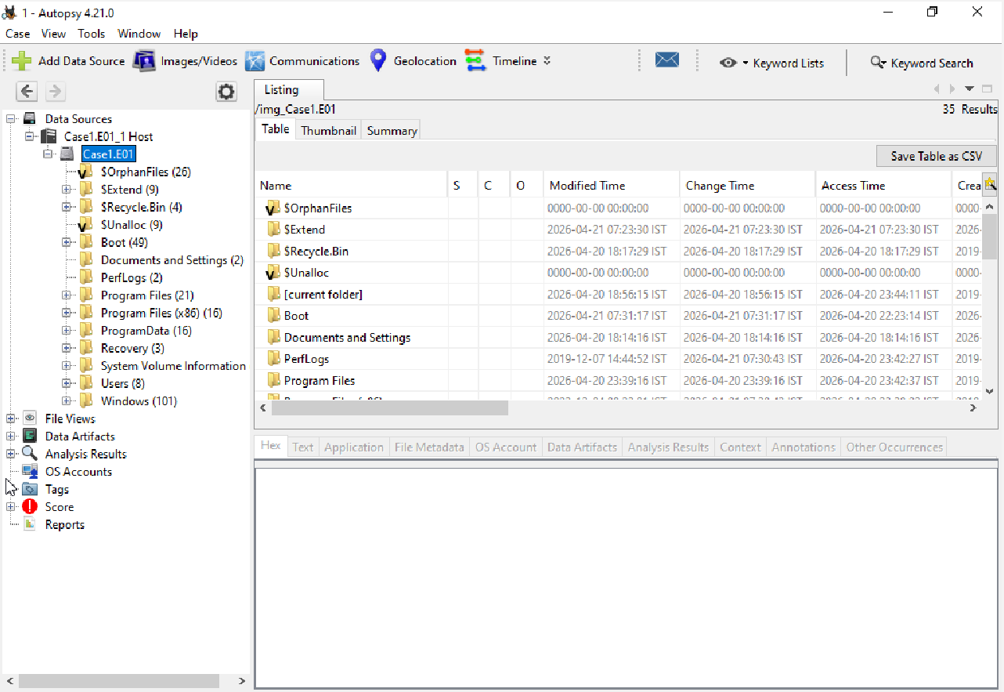

2. File Type Analysis
File type analysis was performed using the “By Extension” feature in Autopsy. The screenshot shows different executable files (.exe) such as OneDriveSetup.exe, FileCoAuth.exe, and other system-related programs.
The presence of these executable files indicates program activity within the system. This analysis helps in identifying installed or executed applications and understanding system usage patterns.
Examining file types is important in forensic investigations as it helps detect suspicious or unauthorized programs.
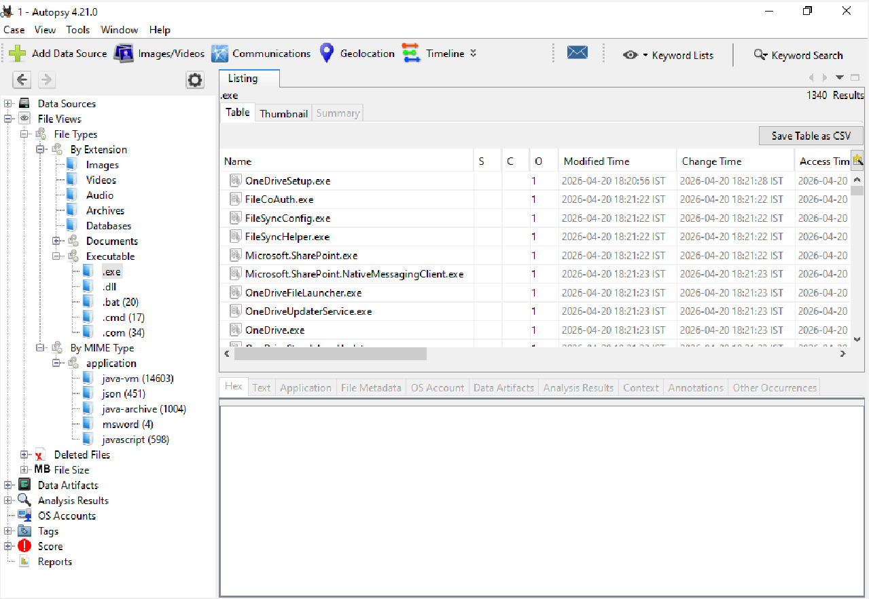

3. Deleted Files Analysis
The deleted files were analyzed using Autopsy to identify data that had been removed from the system. The screenshot shows a list of deleted files, including executable files such as python3.exe and python.exe, along with other system-related files.
The presence of deleted executable files indicates previous program activity within the system. In a forensic investigation, such deletions may suggest an attempt to remove traces of activity or hide certain information.
The analysis of deleted files provides valuable insights into past system usage and helps in understanding actions performed by the user.

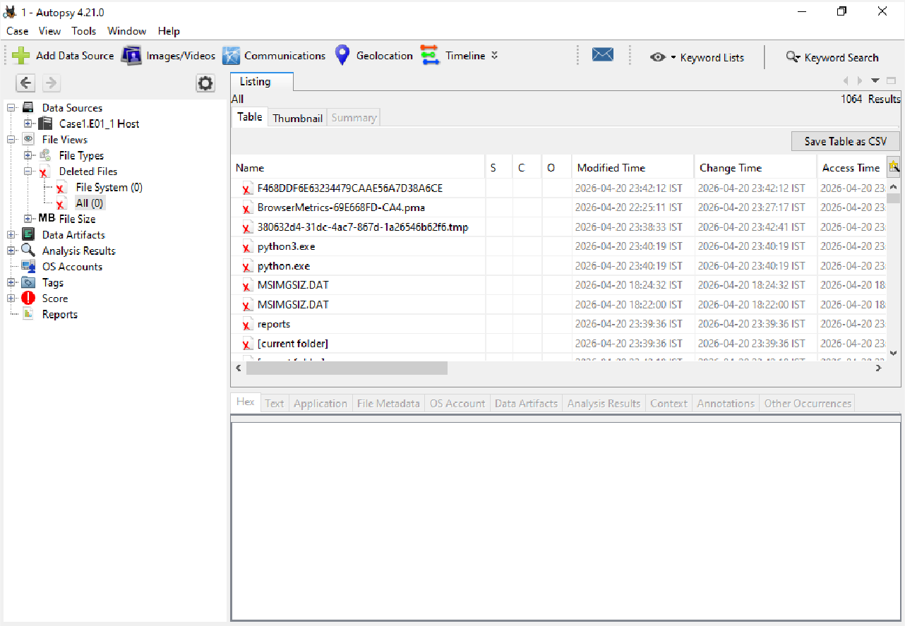

4. Timeline Analysis
Timeline analysis was performed using Autopsy to examine system activity over a period of time. The screenshot shows a list of events with their corresponding date, time, and file paths.
This analysis helps in identifying important events such as file creation, modification, and access. It provides a chronological view of system activity, which is useful for understanding user actions and system behavior.
By analyzing the timeline, patterns of system usage can be identified, and any unusual or unexpected activity can be detected effectively.

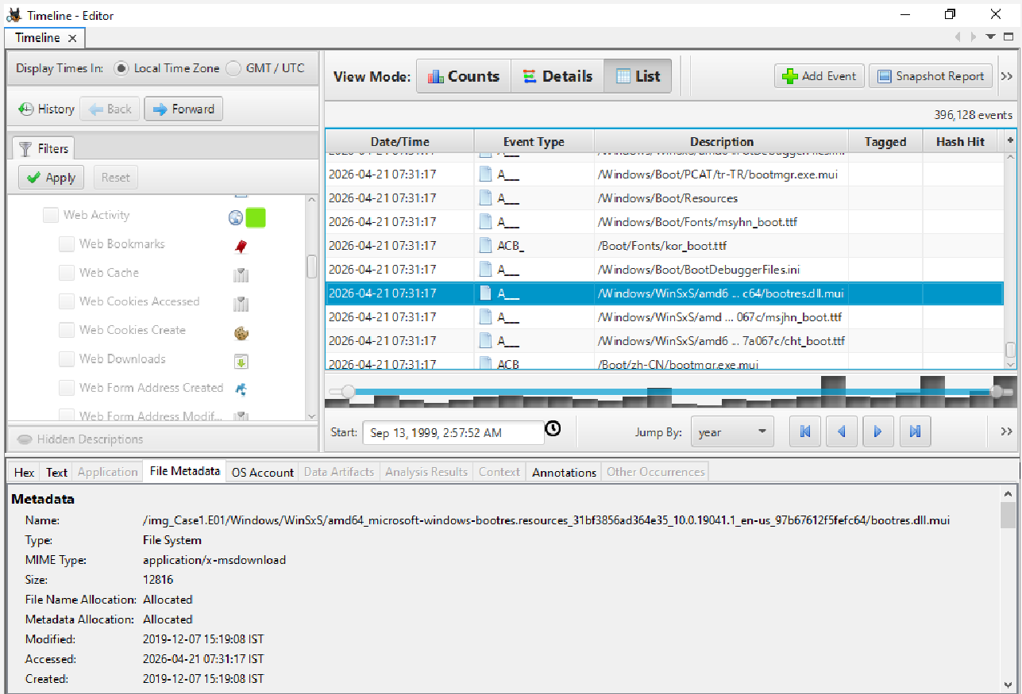

5. Analysis Results
The analysis results were generated using Autopsy after processing the disk image. The screenshot shows various categories such as Encryption Detected, Encryption Suspected, EXIF Metadata, Extension Mismatch Detected, and User Content Suspected.
A large number of extension mismatches were identified, which may indicate the presence of disguised or modified files. Encrypted and suspected encrypted files were also detected, suggesting the use of data protection or concealment techniques.
Additionally, web-related artifacts and user content were identified, providing insights into system usage and user activity. These results help in identifying potential indicators of suspicious behavior within the system.

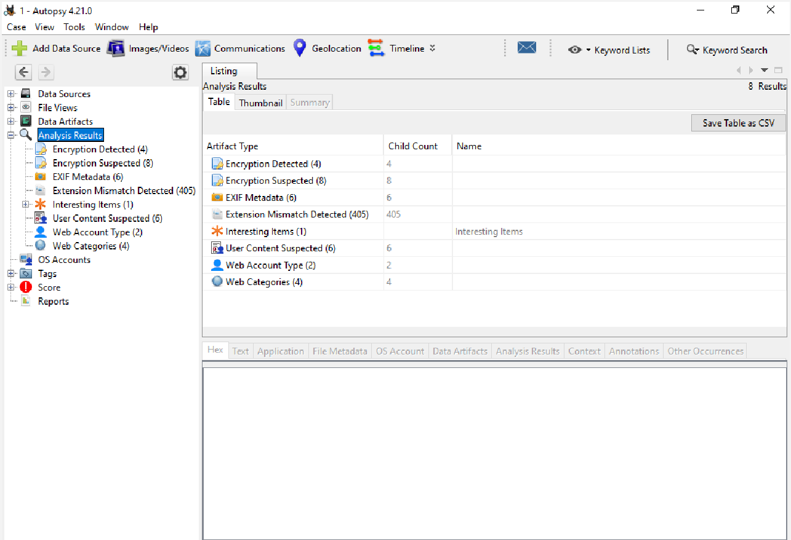

6. User Activity / Data Artifacts Analysis
The data artifacts were analyzed using Autopsy to examine user activity and system-generated information. The screenshot shows various categories such as installed programs, recent documents, web activity, communication accounts, and metadata.
These artifacts provide important insights into user behavior and system usage patterns. Information such as web history, downloads, and recently accessed files helps in understanding how the system was used.
The presence of installed programs and communication data further supports the analysis of user interactions and system operations. This type of analysis is essential in digital forensics for reconstructing user activity.

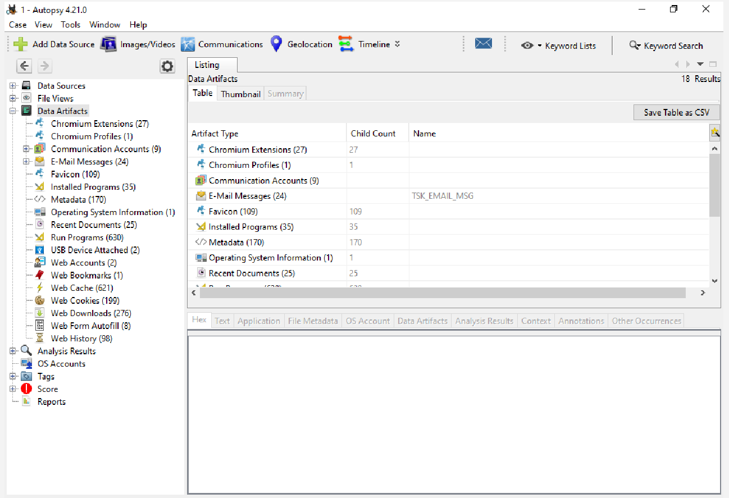

● Project GitHub Link
The complete project, including the report, screenshots, and documentation, is available at:
https://github.com/pm0641
Learning and Reflection
This project provided a valuable learning experience in the field of digital forensics and cybersecurity. It offered practical exposure to forensic tools and techniques that are commonly used in real-world investigations.
From a technical perspective, the project helped in understanding the use of tools such as FTK Imager for disk imaging and Autopsy for forensic analysis. It enhanced skills in analyzing file systems, identifying deleted files, and interpreting timeline and timestamp data. It also improved the ability to differentiate between valid and invalid timestamps and draw logical conclusions from limited data.
From a management perspective, the project contributed to the development of planning, problem-solving, and analytical thinking skills. It required a structured approach to investigation along with proper documentation, which helped in improving organization and reporting abilities.
Overall, this project was highly beneficial as it provided hands-on experience in digital forensic processes. It improved confidence in using forensic tools and strengthened the ability to analyze and interpret digital evidence effectively in real-world scenarios.

Conclusion and Future Scope
The objective of this project was to perform digital forensic analysis on a system disk image using FTK Imager and Autopsy. The project successfully achieved its goals by acquiring a forensic image, analyzing file systems, identifying deleted files, and examining timeline and timestamp data.
The analysis provided useful insights into system activity and user behavior. Although limited artifacts were available due to a recent system reset, meaningful information was still obtained through deleted files and timeline analysis. Based on the findings, the system showed normal usage patterns with no clear evidence of suspicious or malicious activity.
Future Scope:
The scope of this project can be extended to more advanced forensic investigations such as network forensics, memory analysis, and malware detection. The analysis can also be improved by working with larger and more complex datasets. Additionally, integrating advanced forensic tools and enhancing data logging and monitoring mechanisms can help in performing more detailed and accurate investigations in future scenarios.

